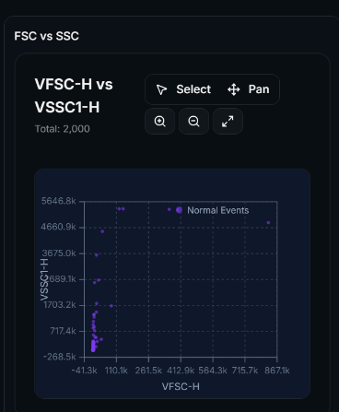
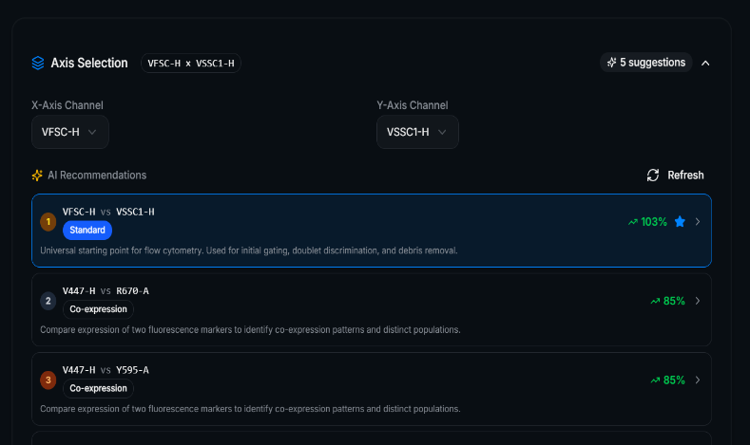

1.Move the Axis Selection to the Graph so they can directly select.
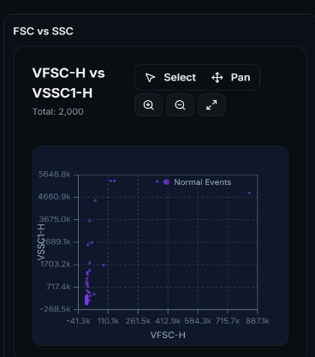

2. The ability to duplicate this graph and change the axis on the original without affecting the duplicate. (The duplicate need not have the change axis ability.)

3. Ability to add up to 5-10 files.
4. The Graph tools in compare tab. (There is no way to choose axis),
5. Graphs not populating in the compare tabs,
6. Ability to pin overlay tab graphs.
6. Compare Different axis from different files.
7. Similar to NTA we need to add the treatment, dye options.

